ACKNOWLEDGEMENT

The satisfaction that accompanies the successful completion of any task would be incomplete without the mention of people who made it possible and whose encouragement and guidance has been a source of inspiration throughout the course of the project.
It is a great pleasure to convey our profound sense of gratitude to our principal Dr.K.Ramamohan Reddy, Dr.A.Vani Vathsala, Head of CSE Department, CVR College of Engineering, for having been kind enough to arrange necessary facilities for executing the project in the college.
We deem it a pleasure to acknowledge our sense of gratitude to our project guide Mr.N.Yadagiri under whom we have carried out the project work. His inclusive and objective guidance and timely advice encouraged us with constant flow of energy to continue the work.
We wish a deep sense of gratitude and heartfelt thanks to management for providing excellent lab facilities and tools. Finally, we thank all those whose guidance helped us in this regard.

Project Coordinator
Dr.N Subhash Chandra
Professor

ABSTRACT
Podcasts have emerged as a widely used medium for delivering information, education, and entertainment in the digital era. However, most existing podcast platforms primarily focus on content distribution and provide limited support for structured content management, user interaction, and administrative control. These limitations make them less suitable for environments such as educational institutions and community platforms, where organized content handling and moderation are essential.
This project presents Podmate, a role-based podcast management and streaming web application designed to address these challenges. The platform integrates podcast streaming, content management, and user interaction within a unified system. It supports multiple user roles—users, creators, and administrators—each with specific functionalities. Users can discover, stream, and interact with podcasts through features like likes, comments, bookmarks, and subscriptions, while creators can upload and manage content. Administrators are provided with tools for monitoring platform activity, moderating content, and managing users effectively.
PodMate is developed using the MERN stack (MongoDB, Express.js, React.js, and Node.js) and follows a scalable three-tier architecture. Secure authentication is implemented using JSON Web Tokens (JWT) to ensure controlled access to system resources. The system demonstrates reliable performance in streaming, data handling, and role-based operations, offering a flexible and efficient solution for podcast management. Overall, PodMate bridges the gap between traditional podcast platforms and structured content management systems.

TABLE OF CONTENTS
 |  |  | Page No
 |  | List of Figures | iv
 |  | Abbreviations | v
1 |  | INTRODUCTION
 | 1.1 | Motivation | 1-2
 | 1.2 | Problem Statement | 2-3
 | 1.3 | Project Objectives | 3
 | 1.4 | Project Report Organization | 3-7
2 |  | LITERATURE REVIEW
 | 2.1 | Existing Work | 8
 | 2.2 | Limitations of Existing work | 8-9
3 |  | REQUIREMENT ANALYSIS
 | 3.1 | Software requirements | 10
 | 3.2 | Hardware requirements | 11
 | 3.3 | User requirements | 11-12
 | 3.4 | Functional requirements | 13
 | 3.5 | Non-Functional requirements | 14
4 |  | SYSTEM DESIGN
 | 4.1 | Proposed System architecture | 15-16
 | 4.2 | Proposed methods/ Algorithms | 16-17
 | 4.3 | UML Diagrams | 18-22
 | 4.4 | Datasets and Technology stack | 23-24
5 |  | IMPLEMENTATION
 | 5.1 | Project Screenshots | 25-26
 | 5.2 | Results and Discussion | 27
 | 5.3 | Testing | 28-29
 | 5.4 | Validation | 30-31
6 |  | CONCLUSION
 | 6.1 | Conclusion | 32
 | 6.2 | Future scope | 33-35
 |  | REFERENCES | 36
 |  | APPENDIX: (If any like Published paper / source code).

LIST OF FIGURES
S.No. | Title | Page No.
4.3.1 | Podmate Use Case Diagram | 18
4.3.2 | Podmate Class Diagram | 19
4.3.3 | Podmate Activity Diagram | 20
4.3.4 | Podmate Sequence Diagram | 21
4.3.5 | Podmate Architecture Diagram | 22
5.1.1 | Welcome Page | 25
5.1.2 | User Dashboard | 25
5.1.3 | User Explore Page | 26
5.1.4 | Podcast Upload Page | 26
5.1.5 | Admin Dashboard | 26

ABBREVIATIONS
Abbreviation | Full Form
AI | Artificial Intelligence
API | Application Programming Interface
AWS | Amazon Web Services
CSS | Cascading Style Sheets
DB | Database
HTML | HyperText Markup Language
HTTP | HyperText Transfer Protocol
JWT | JSON Web Token
MERN | MongoDB, Express.js, React.js, Node.js
MDN | Mozilla Developer Network
NoSQL | Not Only Structured Query Language
WA | Progressive Web Application
REST | Representational State Transfer
SEO | Search Engine Optimization
UI | User Interface
UX | User Experience
UAT | User Acceptance Testing
WCAG | Web Content Accessibility Guidelines

1. INTRODUCTION
1.1 Motivation
The growing popularity of podcasts as a medium for learning, entertainment, and expression has led to a surge in content creation. However, most existing platforms offer limited flexibility and accessibility for independent creators and do not provide the tools necessary to build a meaningful connection with listeners. Features such as real-time interaction, discoverability, accessible content formats, and community engagement are often missing or underdeveloped.
Podcast creators often face challenges such as limited visibility, inadequate moderation support, and the lack of features to foster audience growth. Listeners, on the other hand, are constrained by platforms that offer basic streaming functionality without advanced features like bookmarking, offline listening, or comment-based engagement.
A significant gap exists in accessibility as well—many platforms do not cater to users with hearing impairments. Transcripts, if available, are often manually added and rarely integrated into the user experience. This lack of inclusivity limits the platform’s reach and discoverability.
Podmate is motivated by the need to build a platform that addresses these gaps through a feature-rich, modular design. Podmate empowers creators to grow organically while offering listeners a more interactive, personalized, and inclusive experience. The project seeks to create a well-balanced ecosystem where podcasting is not only about uploading and streaming but also about accessibility, discovery, engagement, and community building.
Furthermore, the rapid advancement of web technologies and cloud-based solutions has created an opportunity to develop scalable and efficient platforms that can support large volumes of multimedia content and user interactions. By leveraging modern frameworks and APIs, Podmate aims to deliver a seamless and responsive experience across devices while ensuring high performance and reliability. The integration of intelligent features such as automated transcription, content moderation, and personalized recommendations enhances both usability and accessibility, making the platform adaptable to diverse user needs.
In addition, the increasing demand for community-driven platforms highlights the importance of fostering meaningful engagement between creators and listeners. Podmate is designed to bridge this gap by enabling direct interaction through comments, reviews, and subscription-based support. This not only helps creators build a loyal audience but also encourages active participation from listeners. By combining content creation, discovery, and community engagement into a single platform, Podmate aspires to redefine the podcasting experience and support the sustainable growth of the podcast ecosystem.

1.2 Problem Statement
Title: Podmate - Your Personalised Podcast Manager
Description:
In the current podcasting landscape, creators often face challenges in effectively distributing their content, building a strong community around their shows, and monetizing their efforts. Many platforms offer basic hosting but lack robust tools for audience engagement and interaction. Listeners, on the other hand, struggle to discover new and relevant podcasts and often lack a centralized space to connect with creators and fellow fans.
This project seeks to address these challenges by creating a platform that empowers podcasters to easily upload, manage, and distribute their content while providing them with tools to foster a thriving community. Additionally, the system aims to enhance the listener experience by offering improved search and discovery features, as well as opportunities for direct interaction with creators and other listeners.
Furthermore, existing platforms often lack advanced features such as personalized recommendations, efficient content moderation, and accessibility support like automated transcription. These limitations reduce the overall user experience and hinder the growth of both creators and listeners. There is also a need for a unified platform that integrates content creation, management, engagement, and analytics in a seamless manner.
Podmate aims to overcome these issues by providing a comprehensive solution that combines ease of use, scalability, and advanced functionalities. By integrating modern technologies and user-centric design principles, the platform strives to create an inclusive, interactive, and efficient ecosystem that supports both content creators and listeners in achieving their goals.

1.3 Project Objectives
The primary objectives of the Podmate project are as follows:
- To develop an intuitive platform where podcast creators can easily upload, manage, and distribute their audio and video content without requiring intermediaries.
- To enable listeners to efficiently search for and discover new podcasts based on various criteria such as title, keywords, categories, and creator.
- To implement interactive features that allow listeners to engage with podcast content through playback controls, episode downloading, bookmarking, and playlist creation.
- To facilitate direct interaction and community building between creators and listeners through features like comments, reviews, and potentially forums.
- To provide creators with tools to understand their audience through basic analytics and to explore monetization options such as subscription tiers.
- To create an administrative interface that allows platform oversight, user management, content moderation, and ensures the security and stability of the Podmate ecosystem.
- To ensure a seamless and responsive user experience across different devices, including desktops, tablets, and mobile platforms.

1.4 Project Report Organization
This report details the development of Podmate, a comprehensive web-based platform designed to revolutionize podcast creation, distribution, and community engagement. Built with a modern technology stack, Podmate offers features such as podcast uploading, enhanced search and discovery, community forums, user subscriptions, monetization tools, and video-to-text transcription to address the evolving needs of podcasters and listeners.
1.4.1 Title Page
- Project Title: Podmate: A Platform for Enhanced Podcast Creation, Distribution, and Community Engagement
- Developers' Names: T.Renuka, I.Sneha , M.Sreeja
- Institutional Affiliation: CVR College of Engineering

1.4.2 Abstract
- A brief summary of the Podmate project, including its purpose, key features (podcast hosting, community features, video-to-text), and the specific technologies employed for each module.
- The abstract will highlight Podmate's modular architecture and the role of the Admin Module in platform management.

1.4.3 Table of Contents
- List of all sections and subsections with page numbers, providing a clear navigation structure.

1.4.4 Introduction
- Background and Context: The current state of podcasting, challenges faced by creators (distribution, engagement), the need for accessibility, and how Podmate addresses these.
- Purpose and Significance: Project objectives, detailing how Podmate benefits podcasters (management, monetization) and listeners (discovery, interaction, accessibility).

1.4.5 System Analysis
- Problem Definition: Detailed issues in the podcasting ecosystem (limited tools, discoverability, community, accessibility).
- Objectives: Goals Podmate aims to achieve (creator empowerment, community, accessibility, user-friendly platform).
- Proposed System: Summary of how Podmate solves problems with a feature-rich, accessible platform.

1.4.6 System Design
- Architecture: Podmate's architecture, with diagrams showing module interactions.
- Modules:
  - User Authentication Module:
    - Description: Manages user registration, login, and roles.
    - Tech Stack: JWT, bcrypt.js, Express.js, MongoDB
  - User Dashboard / Channel Module:
    - Description: Provides user channels, podcast management, follower count.
    - Tech Stack: React.js, Node.js, MongoDB, Express.js, Tailwind CSS
  - Podcast Upload Module:
      - Description: Enables podcast uploads with title, description, and file input.
      - Tech Stack: React.js, Multer, Cloudinary, Express.js, MongoDB
  - Content Moderation Module:
      - Description: Moderates content (automated and admin approval).
      - Tech Stack: Content Moderator API , Admin Panel (React), Express.js
  - Podcast Listening Module:
    - Description: In-browser audio player with resume playback.
      - Tech Stack: React Player/HTML5 Audio, React.js, MongoDB
  - Bookmark & Download Module:
      - Description: Bookmarking and downloading episodes.
      - Tech Stack: React.js, Node.js, MongoDB, S3/Cloudinary
  - Search & Discovery Module:
      - Description: Podcast search by title, category, tags; external API integration.
      - Tech Stack: Listen Notes API, Axios, React.js
  - Admin Dashboard:
      - Description: Admin tools for user/content management.
      - Tech Stack: React.js, Express.js, MongoDB
  - Analytics Dashboard:
      - Description: Tracks user engagement, podcast listens.
      - Tech Stack: Chart.js/Recharts, MongoDB aggregation
  - Admin-User Separation & Role Management:
      - Description: Manages access control based on user roles
      - Tech Stack: JWT, Express.js, MongoDB (role-based access), React.js
  - Social Sharing & SEO Features:
      - Description: Episode sharing on social media, SEO optimization.
      - Tech Stack: React-Helmet (SEO), Social Media APIs
  - Unit Testing & Code Quality:
      - Description: Unit testing, code quality checks.
      - Tech Stack: Jest, Mocha, Chai, React Testing Library, Supertest
  - Video-to-Text Transcription Module:
      - Description: Automatic transcription of video podcasts.
      - Tech Stack: AssemblyAI/Google Cloud Speech-to-Text/AWS Transcribe, Node.js, MongoDB
  - User Interface Design:
    - UI wireframes and descriptions for each module, detailing layouts and user interactions.

1.4.7 Technology Stack
- Frontend: React.js, HTML5, CSS3, Tailwind CSS
- Backend: Node.js, Express.js
- Database: MongoDB
- APIs: Listen Notes API, DeepAI/Hive.ai/Microsoft Content Moderator API, AssemblyAI/Google Cloud Speech-to-Text/AWS Transcribe, Social Media APIs
- Other: JWT, bcrypt.js, Multer, Cloudinary, React Player, Axios, Socket.io

1.4.8 Implementation
- Development Process: Agile methodology, sprints, version control (Git).
- Module Implementation: Detailed explanation of the implementation of each module
- Integration: How modules and components were integrated.

1.4.9 Testing
- Testing Strategy: Unit, integration, system testing.
- Test Cases: Examples for key features.
- Bug Fixes: Summary of bugs and resolutions.

1.4.10 Results and Discussion
- Achievements: Key features implemented.
- Performance: Metrics for speed, scalability.
- User Feedback: Initial user feedback.

1.4.11 Conclusion
- Summary: Project recap.
- Lessons Learned: Development insights.
- Future Scope: Potential enhancements.

1.4.12. References
- List of all sources.

2. LITERATURE REVIEW
2.1 Existing Work
The podcasting ecosystem has witnessed significant growth, with numerous platforms providing tools for content creation, hosting, and distribution. Platforms such as SoundCloud, Podbean, and Anchor enable creators to upload and distribute audio content efficiently, offering features like RSS feed generation, embedded players, and basic analytics. These platforms have simplified the process of publishing podcasts and have contributed to the widespread adoption of podcasting as a medium.
In addition, monetization platforms like Patreon and Buy Me a Coffee allow creators to earn revenue through subscriptions, donations, and exclusive content. However, these platforms operate independently and are not specifically designed for podcast management, leading to fragmented workflows for creators.
Major distribution platforms such as Spotify and Apple Podcasts play a crucial role in reaching a wide audience, but their focus is primarily on content consumption rather than providing comprehensive tools for creators. While they have started introducing creator-focused features, aspects such as community interaction, direct engagement, and advanced analytics are still limited.
Furthermore, with the rise of video podcasts, there is an increasing demand for platforms that support multimedia content along with accessibility features like transcription. Although some platforms have begun to adopt such features, they are often not fully integrated, highlighting the need for a more unified and feature-rich solution.

2.2 Limitations of Existing Work
Despite the availability of multiple podcasting platforms, several limitations persist that affect both creators and listeners. One of the major challenges is the lack of integrated community features, which restricts meaningful interaction between creators and their audience. Most platforms provide basic comment or feedback options but do not support comprehensive community-building tools such as forums or real-time engagement.
Monetization remains another significant limitation, as many platforms offer limited or external options, making it difficult for creators to generate sustainable income directly through the platform. This often forces creators to rely on multiple services, increasing complexity and reducing efficiency.
Podcast discovery is also a key concern, as existing search and recommendation systems are often not optimized to provide personalized or relevant content to users. This makes it difficult for new or niche creators to gain visibility and for listeners to find content that matches their interests.
Accessibility is another area where current platforms fall short, particularly in supporting users with hearing impairments. Features such as automatic transcription and captioning are either absent or not seamlessly integrated, limiting inclusivity.
Additionally, creators often lack access to detailed analytics that can help them understand audience behavior, engagement patterns, and content performance. These insights are crucial for improving content strategy and growing their audience, and their absence highlights the need for a more advanced and user-centric platform like Podmate.

3. REQUIREMENT ANALYSIS
3.1 Software Requirements
Podmate is a web-based platform designed to provide a robust, scalable, and flexible architecture. Below are the specific software requirements
- Backend:
  - Node.js: For server-side logic and handling asynchronous tasks.
  - Express.js: To build the backend framework for handling HTTP requests and routing.
  - MongoDB: As the database to store user profiles, podcast metadata, community data, and other necessary information.
- Frontend:
  - React.js: To provide an interactive and responsive user interface for both creators and listeners.
  - HTML5, CSS3, JavaScript: For basic UI structure, styling, and interactivity.
- APIs:
  - Listen Notes API: For integrating podcast search and discovery features.
  - DeepAI/Hive.ai/Microsoft Content Moderator API: For content moderation.
  - AssemblyAI/Google Cloud Speech-to-Text/AWS Transcribe: For video-to-text transcription.
  - Social Media APIs: For social sharing functionality
- Development Tools:
  - Visual Studio Code: As the primary development environment.
  - Postman: For testing API endpoints.
  - Git: For version control and collaboration.
- Other Tools:
  - JWT (JSON Web Tokens): For secure user authentication and role-based access control (creator, listener, admin).
  - Bcrypt: For password encryption.
  - Multer: For handling file uploads (podcasts)
3.2 Hardware Requirements
- Cloud Hosting: A scalable cloud server (AWS, DigitalOcean, etc.) capable of running the MERN stack.
- Recommended configurations include:
  - CPU: Multi-core processor (Intel i5 equivalent or higher).
  - Memory: At least 16GB RAM for handling user traffic and data processing.
  - Storage: SSD storage for fast data retrieval, with space to accommodate a growing database of property listings, user profiles, and chat logs.
- Modern desktop or mobile devices with access to internet browsers such as Google Chrome, Firefox, or Safari.
- No specific hardware requirements for users beyond an internet connection and browser.

3.3 User Requirements
The platform will cater to four user categories:
- General Users
- Creators
- Listeners
- Admins

3.3.1 General Users:
- Registration and Login:
  - Users should be able to register on the platform using a standard set of credentials (e.g., email, username, password).
  - Users should be able to log in securely to the platform and manage their profiles (e.g., update profile information, change password).
- Profile Management: Users should be able to manage their profiles

3.3.2 Creator-Specific Requirements:
- Channel Creation and Management: Creators should be able to create and customize their podcast channels.
- Podcast Upload and Management: Creators should be able to upload and manage their podcast content.
- Content Moderation: Creators should have tools to manage comments and reviews on their podcasts.
- Subscription and Monetization: Creators should be able to set up subscription tiers and manage monetization.
- Analytics: Creators should have access to analytics related to their content and audience.

3.3.3 Listener-Specific Requirements:
- Podcast Search and Discovery: Listeners should be able to search for and discover podcasts.
- Podcast Playback: Listeners should be able to play podcasts within the platform.
- Channel Subscription: Listeners should be able to subscribe to channels.
- Playlist Creation: Listeners should be able to create playlists.
- Community Interaction: Listeners should be able to interact with creators and other listeners.
- Bookmark and Download: Listeners should be able to bookmark and download episodes.

3.3.4 Admins:
- User Management: Admins should be able to manage user accounts.
- Content Moderation: Admins should be able to moderate content on the platform.
- Platform Management: Admins should be able to manage platform settings.
- Analytics: Admins should be able to access platform-wide analytics.

Functional Requirements

Podmate must meet the following functional needs to provide an optimal experience for all users:

User Registration & Authentication:

Secure signup and login for all users with role-based access controls.

Password encryption and recovery.

Podcast Management:

Creators can upload, edit, and delete podcasts with metadata (title, description, tags, etc.).

Creators can schedule podcast releases.

Podcast Playback:

Listeners can play podcasts within the platform.

Playback features (play/pause, skip, volume control).

Community Interaction:

Users can comment on and review podcasts.

Creators and listeners can interact in forums.

Search & Discovery:

Users can search for podcasts by title, keywords, categories, and tags.

The system provides podcast recommendations.

Channel Subscription:

Listeners can subscribe to creator channels.

Notifications for new episodes.

Analytics:

Creators can access analytics on their audience and content.

Admins can access platform-wide analytics.

Admin Panel:

Ability to manage users, podcasts, and system settings.

Content moderation tools.

3.5 Non-Functional Requirements
- Performance:
  - The system should handle a large number of concurrent users and podcast uploads efficiently.
  - Fast loading and playback of podcasts, with minimal buffering.
  - Quick response times for search queries and navigation within the platform.
- Scalability:
  - The platform must be able to scale its storage and processing capacity to accommodate a growing library of podcasts and an increasing user base.
  - Efficient handling of increased data volume without performance degradation.
- Security:
  - Ensure secure user authentication and authorization to protect user accounts and content.
  - Protection against common web application vulnerabilities.
  - Secure storage and transmission of sensitive data.
  - Regular security audits and updates to address potential vulnerabilities.
- Usability:
  - The platform should have an intuitive and user-friendly interface for both podcasters and listeners.
  - Easy navigation and search functionality to help users find content quickly.
  - Accessible design to ensure usability for users with disabilities.
  - Responsive design to provide a seamless experience across various devices (desktops, tablets, and smartphones).
- Availability:
  - The platform should have high uptime to ensure continuous access to podcasts and platform features.
  - Reliable infrastructure and redundancy to minimize downtime due to server failures or maintenance.
  - Monitoring and alerting systems to quickly detect and address any issues that may affect availability.
4. SYSTEM DESIGN

4.1 Proposed System architecture
Podmate's architecture is designed to be modular, scalable, and maintainable, allowing for future expansion and feature additions. It follows a layered approach, separating concerns for clear development and deployment.
- Frontend (Client-Side)
  - Built with React.js to create a dynamic and interactive user interface.
  - Handles user interactions, displays podcast listings, manages audio/video playback, and facilitates community engagement.
  - Key features include:
    - Podcast browsing and search
    - User dashboards for creators and listeners
    - Audio/video player controls
    - Comment and review sections
    - Subscription and notification management
- Backend (Server-Side)
  - Developed using Node.js and Express.js to manage server-side logic and API endpoints.
  - Handles user authentication, podcast data management, community features, analytics processing, and communication with the database.
  - Implements RESTful APIs for efficient communication between the frontend and backend.
- Authentication Module
  - Employs JWT (JSON Web Token) for secure user authentication and session management.
  - Manages user registration, login, and role-based access control (creator, listener, admin).
- Admin Module
  - Provides administrators with tools to manage users, podcasts, and platform settings.
  - Enables content moderation, user reporting, and platform analytics.
- Data Layer
  - Uses MongoDB, a NoSQL database, to store user data, podcast metadata, community interactions, and analytics data.
  - Optimized for scalability and flexible data storage.

4.2 Proposed Methods/Algorithms
The Podmate system employs several key methods and algorithms to ensure efficient podcast management, user interaction, and platform functionality.

4.2.1 User Authentication Algorithm (JWT-Based)
- Purpose: To securely verify and manage user sessions for all user types (creators, listeners, admins).
- Process:
  - Users provide login credentials (email/username, password).
  - The system validates these credentials against stored, hashed passwords.
  - Upon successful validation, a JWT is generated, containing user role and ID.
  - This JWT is sent to the client and included in subsequent requests for authorization.
  - Middleware on the server verifies the JWT's validity before granting access to protected resources.

4.2.2 Podcast Upload and Processing Algorithm
- Purpose: To efficiently handle podcast file uploads and metadata management.
- Process:
  - Creators initiate the upload process, providing metadata (title, description, category, tags) and the audio/video file.
  - The server validates file types, sizes, and metadata fields.
  - Uploaded files are stored in cloud storage (e.g., AWS S3, Cloudinary).
  - For video files, an optional transcription process is triggered.
  - Metadata is stored in the database, linked to the uploaded file's storage location.
4.2.3 Podcast Search and Discovery Algorithm
- Purpose: To enable listeners to find relevant podcasts and episodes effectively.
- Process:
  - Listeners input search queries (keywords, phrases, categories, tags).
  - The system searches the podcast metadata in the database.
  - Search results are ranked based on relevance (e.g., keyword frequency, match in title/description, popularity).
  - (Optional) The system may incorporate recommendation algorithms based on user history or trending content.

4.2.4 Content Moderation Algorithm
- Purpose: To automate and manage the moderation of uploaded podcast content.
- Process:
  - Uploaded podcasts may undergo automated checks using a Content Moderator API (e.g., for explicit language).
  - The results of automated checks are flagged for review.
  - Admin users are presented with flagged content in the Admin Dashboard.
  - Admins manually approve or reject podcasts based on moderation guidelines.

4.2.5 Channel Subscription Management
- Purpose: To manage user subscriptions to channels and the associated tier system.
- Process:
  - Listeners can subscribe to creator channels.
  - The system stores subscription relationships in the database.
  - Channel popularity is calculated based on subscriber count and engagement metrics.

4.3 UML Diagrams
4.3.1 Use Case Diagram
The following use case diagram provides a visual representation of the key functionalities of the Podmate platform and how various types of users interact with the system. The primary actors involved are Creators, Listeners, and Admins, each performing distinct operations within the application.
- Creators are responsible for content generation, including podcast uploads, channel management, and interaction with analytics and monetization features.
- Listeners interact with the platform to browse, search, and consume podcast content, as well as engage with the community through comments and reviews.
- Admins oversee the entire platform, handling tasks such as user management, content moderation, and monitoring platform analytics to ensure a smooth and secure user experience.
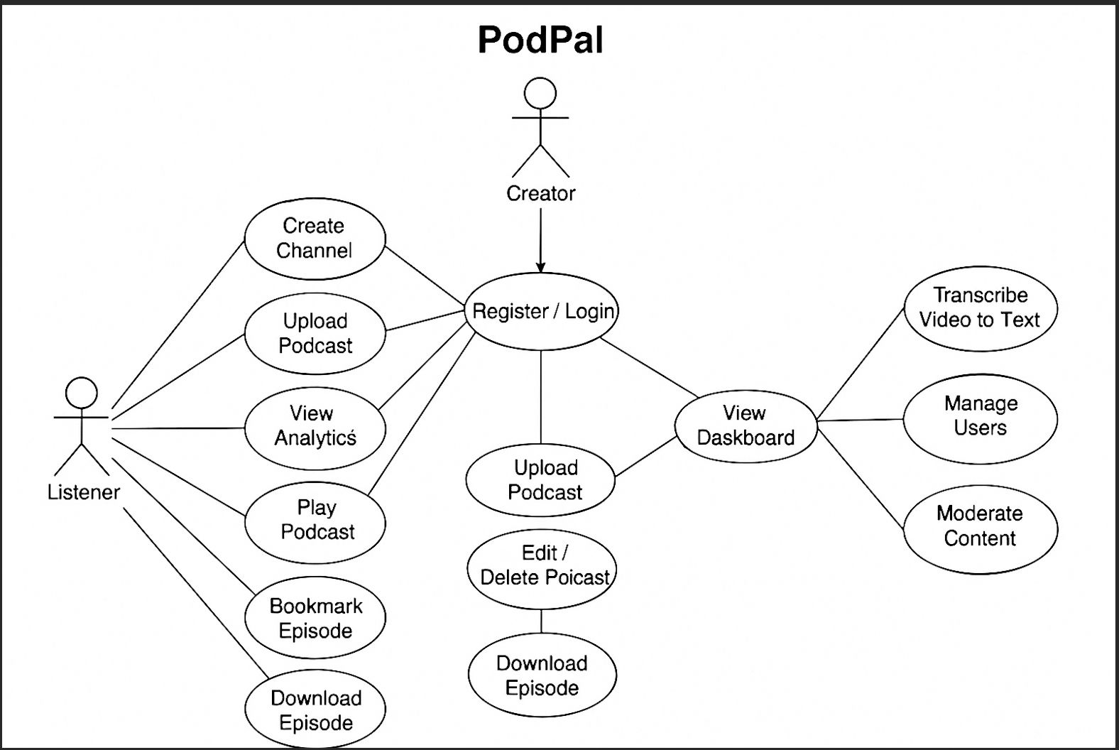
Fig: Podmate Use Case Diagram

4.3.2 Class Diagram
The class diagram represents the structural design of the Podmate system, illustrating the main entities such as users, podcasts, channels, and their relationships. It shows how different components interact to manage podcast creation, user engagement, subscriptions, and data flow within the platform.
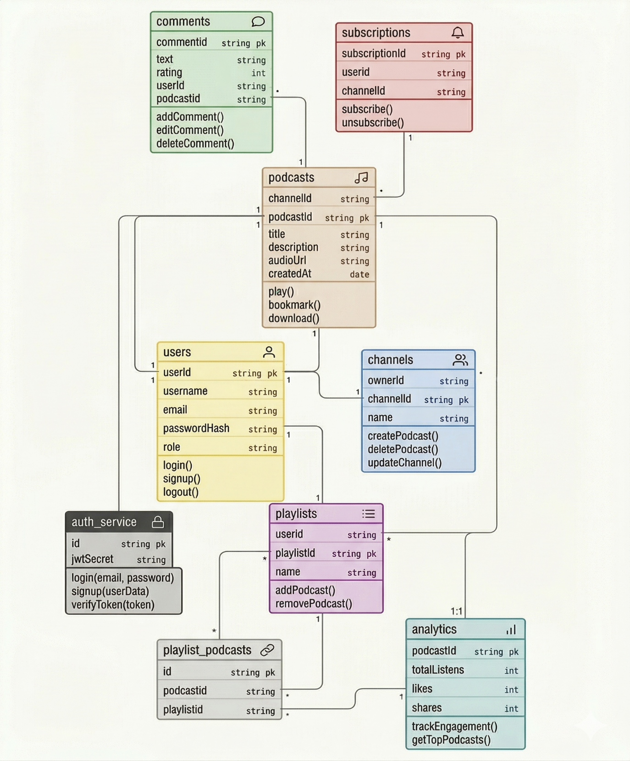
Fig: Podmate Class Diagram
4.3.3 Activity Diagram
The activity diagram begins with user identification, determining whether the user is new or existing. New users proceed with the sign-up process, followed by login to access the platform. After login, users can browse available podcasts, listen to content, and interact by adding comments. In parallel, the system includes an admin/creator workflow for moderating uploaded podcasts. Podcasts are reviewed, and based on approval, they are either published or redirected for further analysis. The system tracks user engagement through analytics, including listens, likes, and interactions.
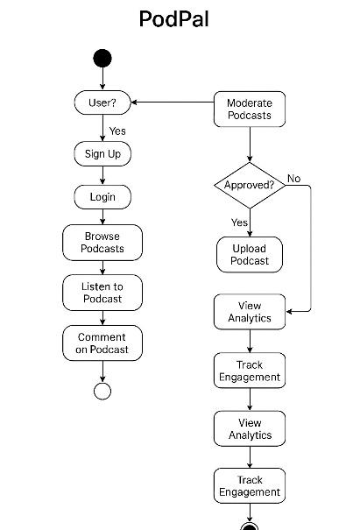
Fig: Podmate Activity Diagram
4.3.4 Sequence Diagram
The sequence diagram represents the interaction between different components of the Podmate system, including the user, admin, frontend, backend, database, cloud storage, and external services. It starts with user authentication, where credentials are validated and a JWT token is generated for secure access. During podcast upload, the frontend sends data to the backend, which stores audio in cloud storage and saves metadata in the database. The podcast is then sent for moderation, and its status is updated based on the moderation results. The admin reviews pending podcasts and approves or rejects them, after which notifications are sent to users. In the listening flow, users browse and play podcasts, while the system retrieves approved content and tracks user engagement.

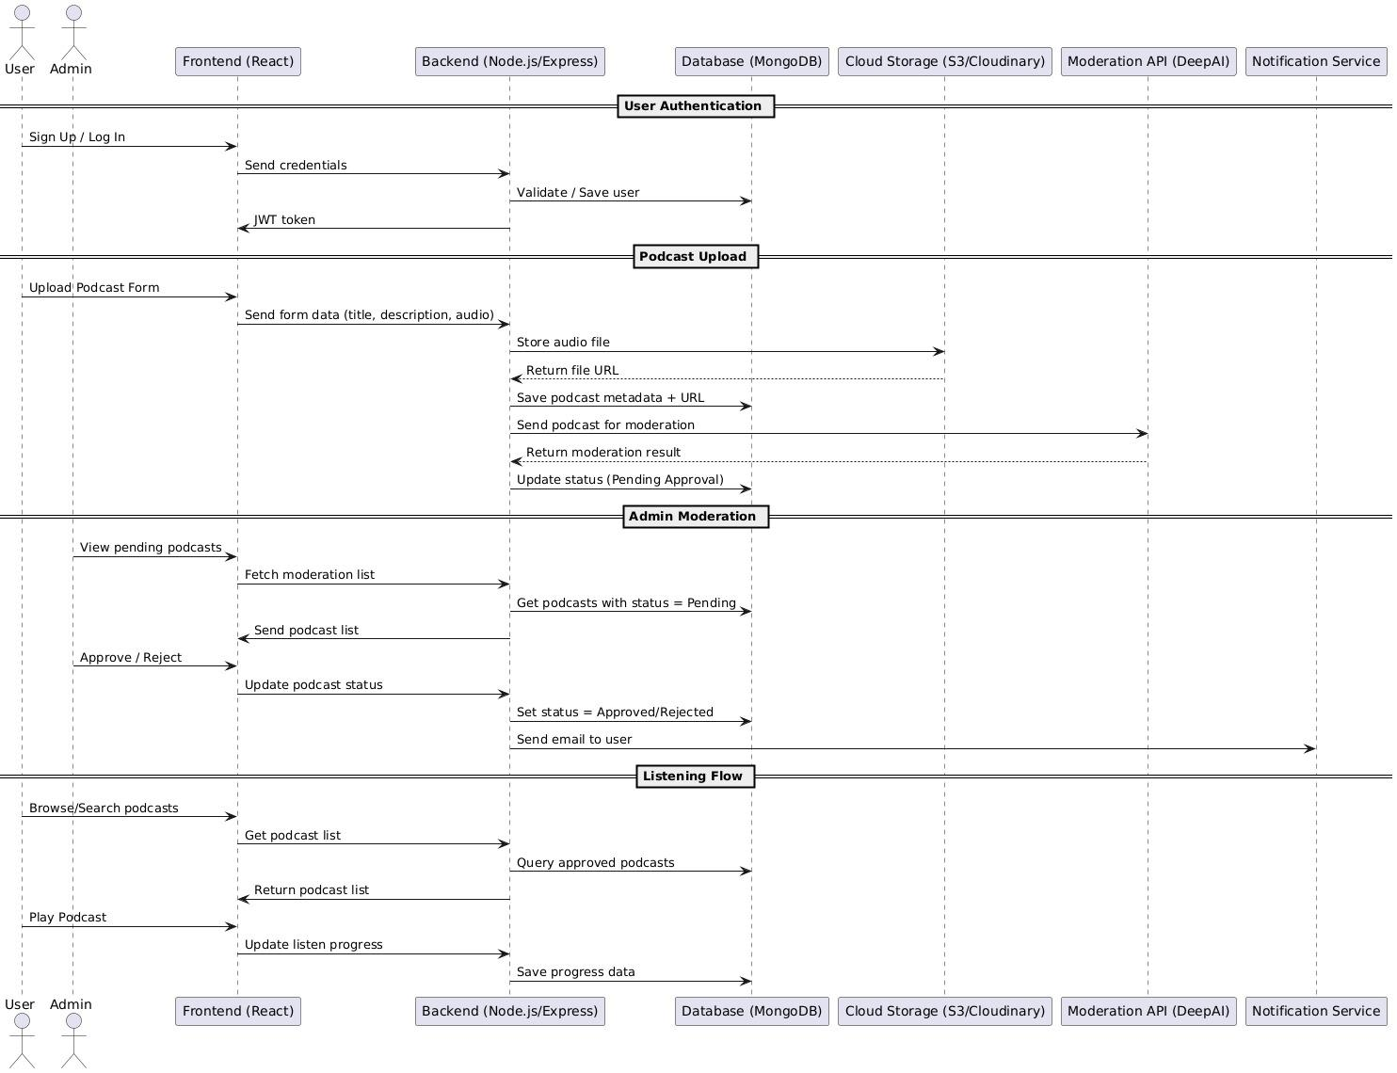
Fig: Podmate Sequence Diagram

4.3.5 Architecture Diagram
The architecture diagram of Podmate illustrates a modular and scalable system comprising frontend, backend, database, and external services. The React-based frontend provides interfaces for listeners, creators, and administrators, while the Node.js and Express backend handles business logic, authentication, and communication between components. The backend interacts with MongoDB for storing user data, podcast metadata, and moderation logs, and integrates with cloud storage for media handling. External APIs such as content moderation, Listen Notes for search, and speech-to-text for transcription enhance platform functionality, while admin notifications ensure proper review of flagged content, resulting in an efficient and robust system design.
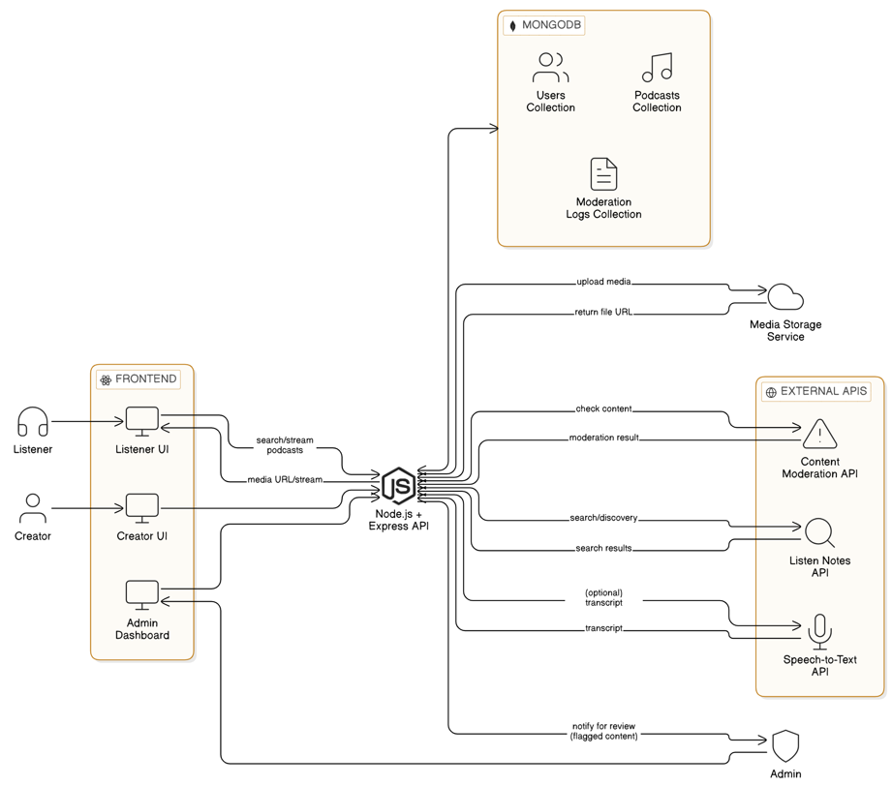
Fig: Podmate Architecture Diagram

4.4 Datasets and Technology Stack
Podmate is a platform for podcast creation, distribution, and community interaction. The data used is primarily user-generated and content-related.
Below are the types of data handled in the system:
- User Data
  - Attributes:
    - Username, Email, Password (hashed), Profile Picture
    - User Role (Creator, Listener, Admin)
    - Channel Details (for Creators)
    - Subscription Information
  - Storage: MongoDB
- Podcast Data
  - Attributes:
    - Podcast Title, Description, Category, Tags
    - Episode Title, Description, Audio/Video File Path
    - Publication Date, Duration
    - Creator ID
    - Transcript (for video podcasts)
  - Storage: MongoDB for metadata, Cloud storage (Cloudinary) for audio/video files
- Analytics Data
  - Attributes:
    - Listener Counts, Playback Duration
    - Download Counts, Demographics
  - Storage: MongoDB
The following table outlines the technology stack used in Podmate:
Component | Technology Used | Description
Frontend | React.js, Tailwind CSS | For building a responsive and interactive user interface
Routing | React Router | For navigation between pages (home, channels, player, etc.)
Backend | Node.js, Express.js | RESTful API for server-side logic, podcast management, user interactions
Database | MongoDB | NoSQL database for storing user data, podcast metadata, community data, etc.
Authentication | JWT (JSON Web Tokens) | Secure login, role-based access control
Media Storage | AWS S3 / Cloudinary | For storing audio/video files and artwork
Transcription | AssemblyAI / Google Cloud Speech-to-Text | For automatic transcription of video podcasts
Real-Time | WebSockets (Socket.io) | For real-time notifications, chat, etc.
Search | Listen Notes API | For enhanced podcast search and discovery
Version Control | Git & GitHub | For source code management
Hosting & Deployment | Vercel | For deploying the application

5. IMPLEMENTATION
5.1 Project Screenshots
5.1.1 Welcome Page
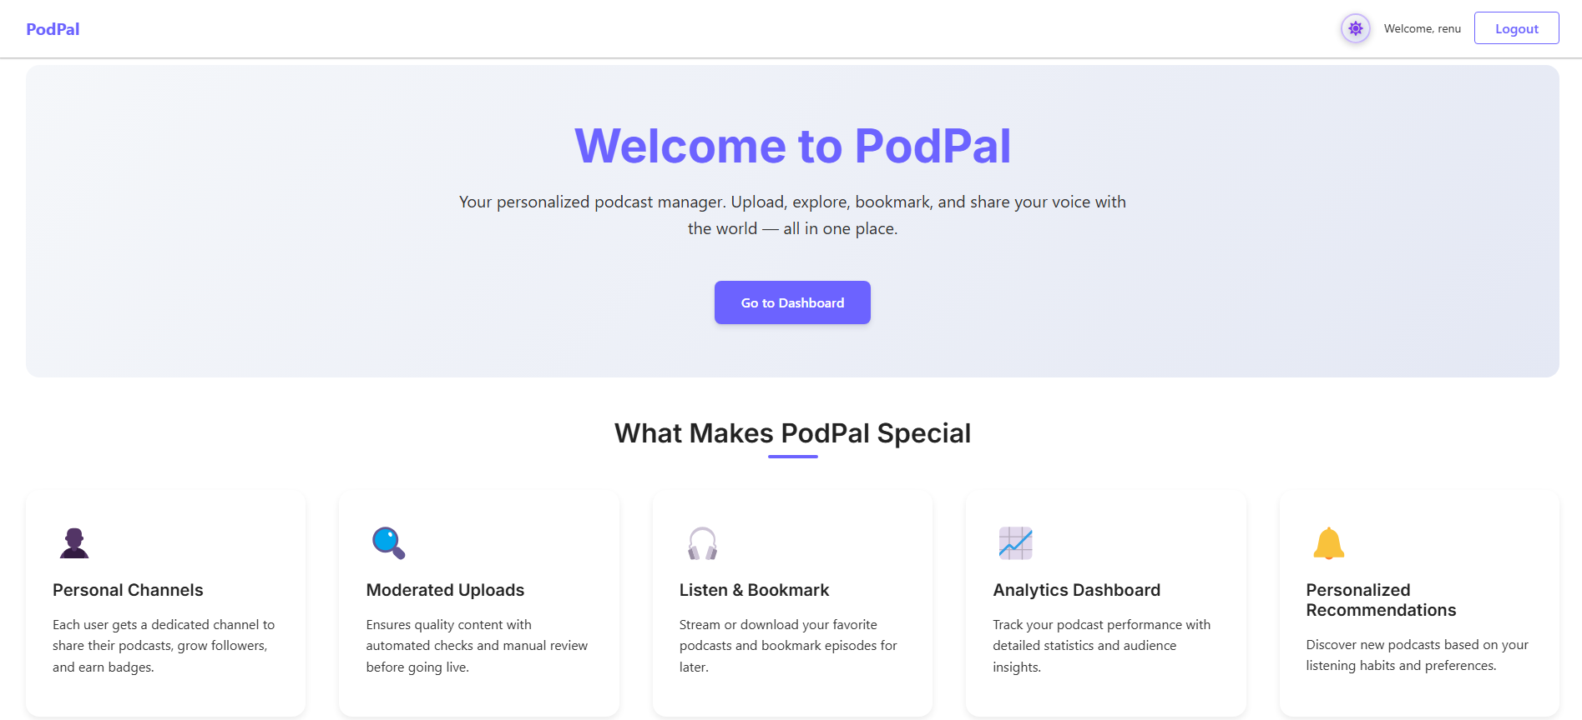
Fig: Podmate Welcome Page

5.1.2 User Dashboard
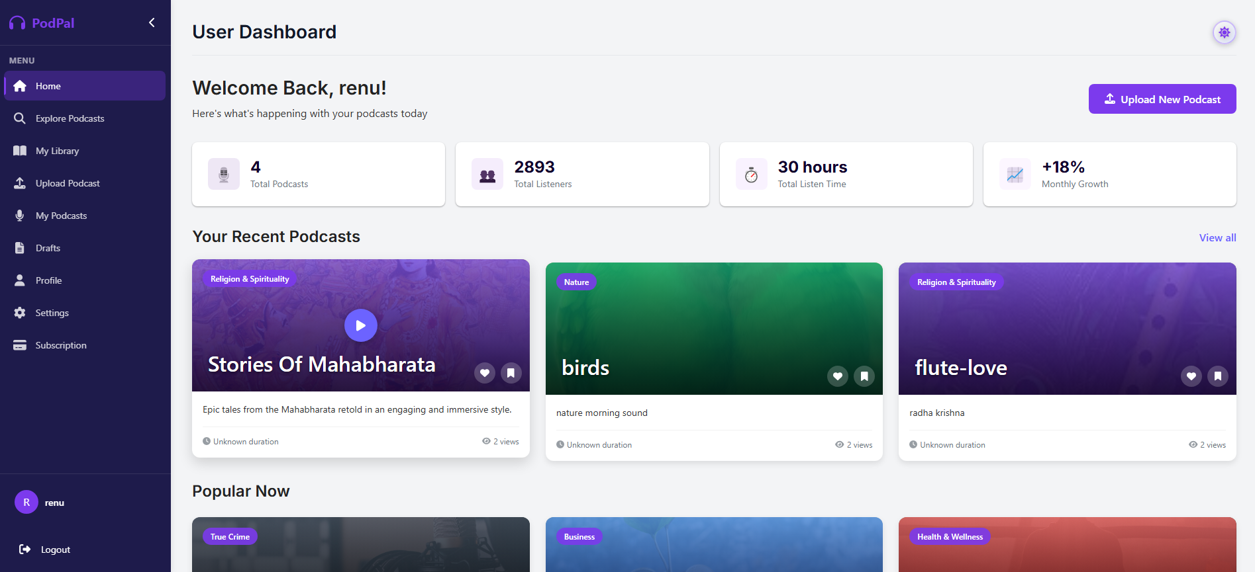
Fig: Podmate User Dashboard

5.1.3 User Explore Page
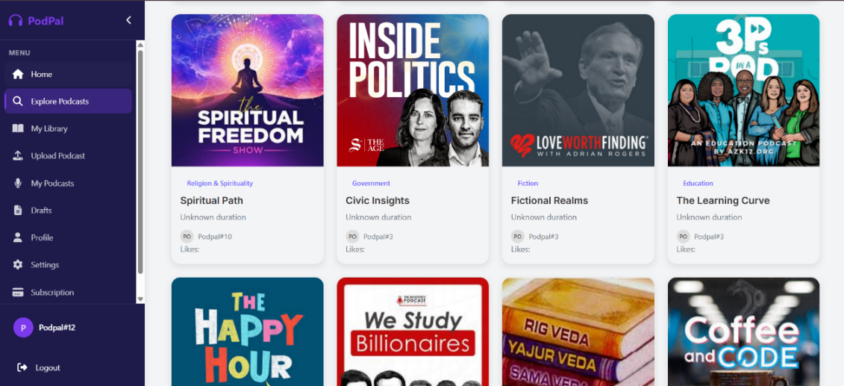
Fig: Podmate User Explore page

5.1.4 Podcast Upload Page
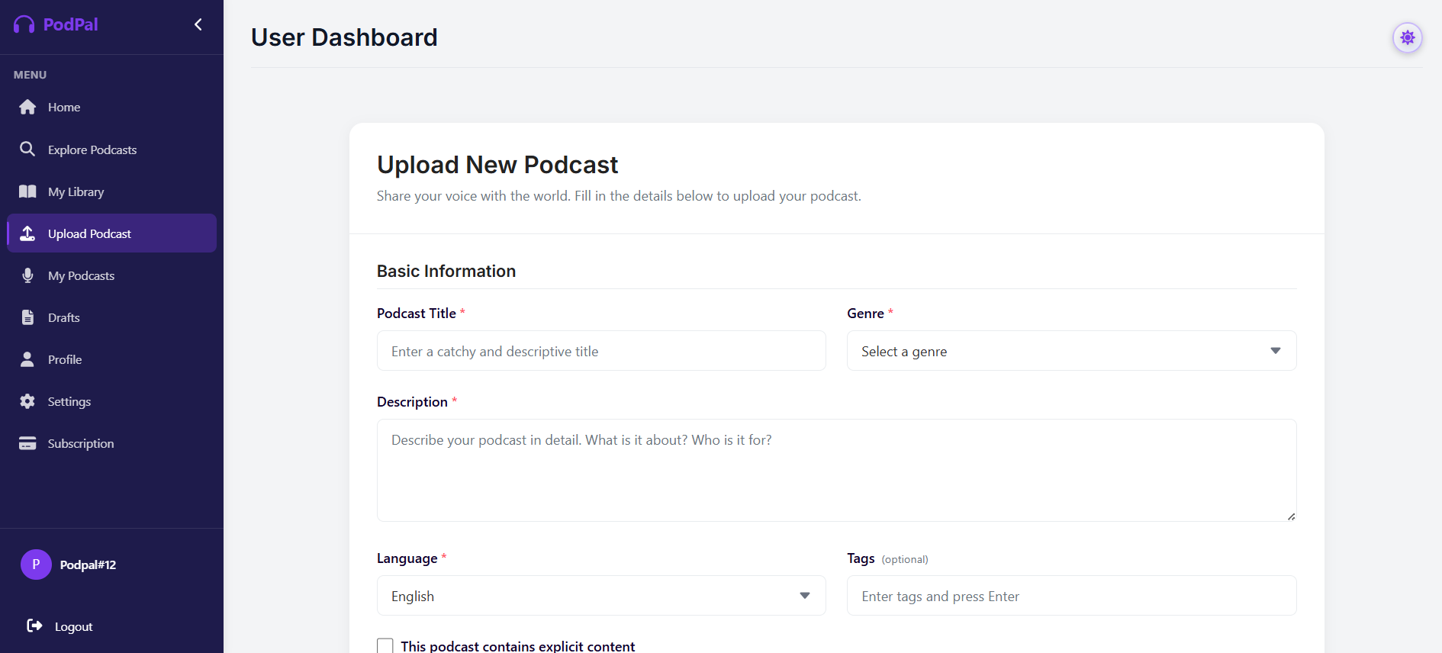
Fig: Podcast Upload Page

5.1.5 Admin Dashboard
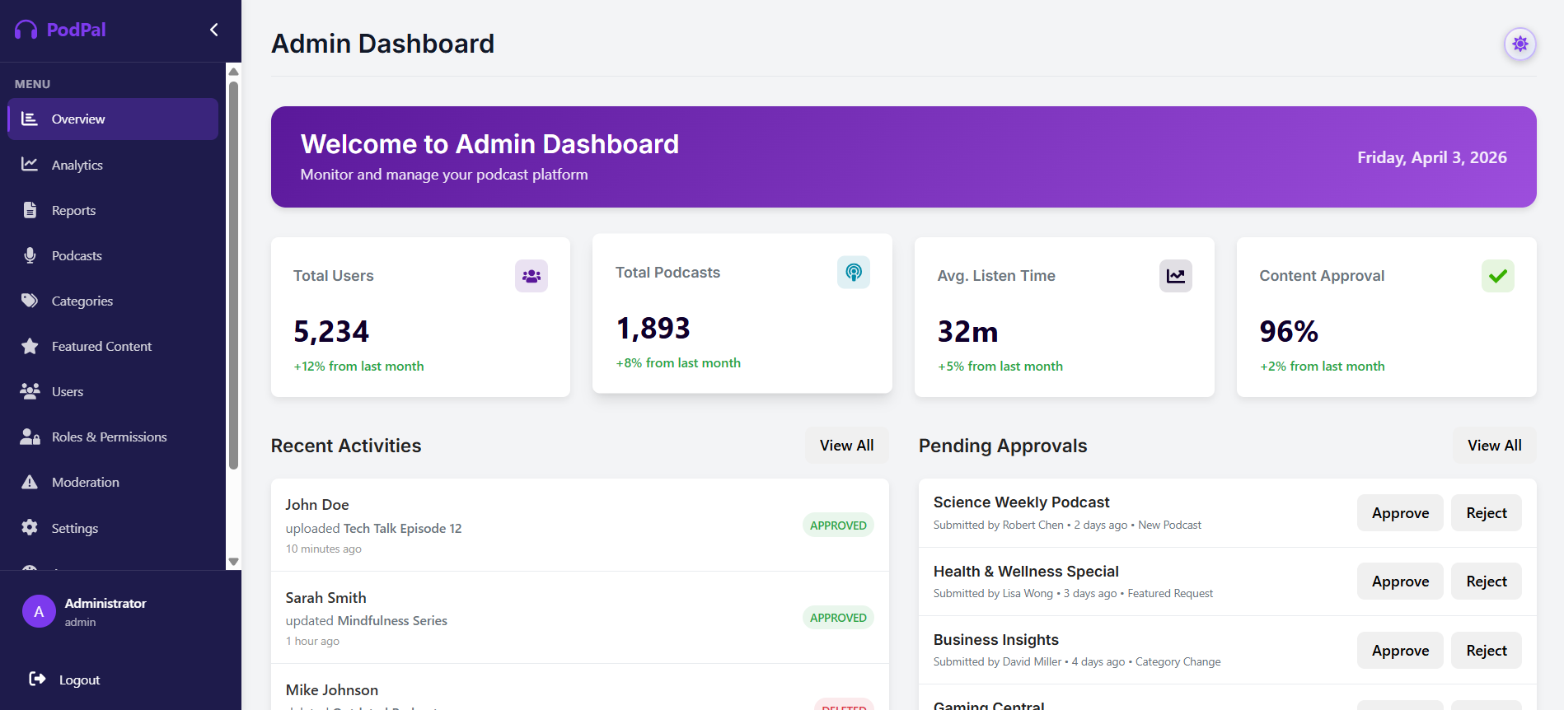
Fig: Podmate Admin Dashboard

5.2 Results and Discussion
5.2.1 System Features Achieved
The Podmate platform was successfully developed and deployed with the following key features:
- User Authentication: Secure user registration and login with role-based access control for creators, listeners, and admins.
- Podcast Management: Creators can upload, edit, and manage their podcasts with detailed metadata.
- Podcast Playback: Listeners can seamlessly play podcasts with standard playback controls.
- Search and Discovery: Robust search functionality enables users to find podcasts by title, keywords, and categories.
- Community Interaction: Users can engage with podcasts through comments, reviews, and forums.
- Admin Panel: Comprehensive admin tools for user management, content moderation, and platform oversight.

5.2.2 Performance Observations
- User Authentication: Secure and efficient login/registration for all user types.
- Podcast Upload: Smooth and reliable podcast uploads with accurate metadata association.
- Podcast Playback: High-quality audio/video playback with minimal buffering.
- Search Functionality: Fast and accurate search results, even with a large podcast library.
- Community Features: Seamless posting and display of comments, reviews, and forum discussions.
- Admin Functions: Effective user and content management capabilities.
- Transcription: Accurate and timely transcription of video podcasts.

5.3 Testing
To ensure the Podmate platform's reliability and quality, a comprehensive testing strategy was implemented, encompassing various testing levels and techniques.

5.3.1 Unit Testing
- Scope: Individual components and functions within the Podmate system were tested in isolation. This included testing functions for user authentication, podcast uploads, search functionality, community interactions, and video-to-text transcription logic.
- Tools Used: Jest and React Testing Library were employed for JavaScript testing to validate the behavior of these components and functions.

5.3.2 Integration Testing
- Scope: The interactions and integrations between different modules of the Podmate system were tested.
- Observed Results:
  - User authentication seamlessly integrated with user profile and channel management.
  - Podcast uploads correctly triggered media storage and metadata indexing.
  - Search functionality accurately retrieved podcasts based on various criteria.
  - Community features (comments, reviews, forums) functioned correctly with user and podcast data.
  - Video uploads initiated and completed the transcription process, linking transcripts to the video.

5.3.3 Functional Testing
- Scope: The overall functionality of the Podmate platform was tested to ensure it met the specified user requirements.
- Observed Results:
  - User Registration & Authentication: User signup and login, including role-based access, functioned as expected.
  - Channel & Podcast Management: Creators could create channels, upload, edit, and delete podcasts effectively.
  - Podcast Playback & Download: Listeners could play and download podcasts with standard controls.
  - Search & Discovery: Podcast search and filtering worked accurately and efficiently.
  - Community Features: Users could post comments, reviews, and participate in forums.
  - Subscription & Monetization: Channel subscriptions and creator tier systems functioned correctly.
  - Admin Functions: Admin users could manage users, content, and platform settings.
  - Video-to-Text Transcription: Video podcast audio was accurately transcribed.

5.3.4 System Testing
- Scope: The entire Podmate system was tested as a whole to evaluate its end-to-end functionality, performance, stability, security, and usability.
- Observed Results:
  - The system demonstrated its ability to handle a significant number of concurrent users.
  - Podcast streaming and downloading were reliable and performed well under load.
  - Search queries returned relevant results quickly.
  - The platform maintained stability during extended use and various user interactions.
  - Basic security measures for user authentication and data protection were validated.

5.4 Validation
The Podmate platform underwent a thorough validation process to ensure it meets the defined user requirements and operates effectively. This process involved various methods to gather feedback and assess the system's performance. Additionally, validation included testing different user scenarios to ensure the system behaves correctly under real-world usage conditions.

5.4.1 User Acceptance Testing (UAT):
- A group of representative users (both podcasters and listeners) were invited to interact with the Podmate platform in a controlled environment.
- They were tasked with performing key functionalities, such as creating channels, uploading podcasts, searching for content, listening to episodes, leaving comments, and managing subscriptions.
- Feedback gathered during UAT sessions was crucial in identifying usability issues and areas for improvement before the final deployment.

5.4.2 Performance Testing:
- Load testing tools were used to simulate a large number of concurrent users accessing the platform.
- This helped to evaluate the system's responsiveness, stability, and scalability under peak load conditions.
- Key metrics such as response times for podcast playback, search query execution, and user interactions were monitored to ensure the platform could handle anticipated user traffic without significant degradation in performance.

5.4.3 Accessibility Audit:
- An accessibility audit was conducted to evaluate Podmate's compliance with accessibility guidelines (e.g., WCAG).
- This involved using automated tools and manual testing to identify and address any barriers that might prevent users with disabilities from accessing the platform effectively.
- Areas such as keyboard navigation, screen reader compatibility, color contrast, and alternative text for images were carefully examined.

5.4.4 Code Review:
- The codebase underwent a comprehensive code review process by experienced developers.
- This helped to identify potential bugs, security vulnerabilities, and areas for code optimization.
- Adherence to coding standards and best practices was also assessed to ensure the maintainability and scalability of the platform.

5.4.5 A/B Testing (Post-Launch):
- Following the initial launch, A/B testing was planned for key user interface elements and features, such as the podcast recommendation algorithm and the layout of the search results page.
- This data-driven approach allows for continuous optimization of the platform based on real user behavior and preferences.

The data and feedback gathered through these validation methods provided valuable insights into the strengths and weaknesses of the Podmate platform, guiding necessary iterations and ensuring a high-quality user experience. These validation activities also helped in improving system reliability, performance, and usability before and after deployment. Continuous evaluation and refinement based on user feedback ensured that the platform remains user-centric, scalable, and aligned with real-world requirements.

6. CONCLUSION

6.1 Conclusion
The Podmate platform represents a comprehensive solution for the evolving needs of the podcasting ecosystem. Through the development and implementation of key modules such as user authentication, podcast management, search and discovery, community interaction, monetization, and video-to-text transcription, Podmate offers a feature-rich environment for both creators and listeners.
The project successfully leveraged a modern technology stack, including React.js for a dynamic frontend and Node.js with Express.js for a robust backend, all underpinned by the flexibility of MongoDB. The integration of external APIs for content moderation, transcription, and enhanced search capabilities further enriches the platform's functionality.
Rigorous testing across various levels, from unit to system testing, along with a thorough validation process involving user acceptance testing and performance evaluations, has ensured the reliability, usability, and scalability of Podmate. The feedback gathered has been instrumental in refining the platform and preparing it for a positive user experience.
In conclusion, Podmate has achieved its objectives of providing a platform that empowers podcast creators with comprehensive tools for content management and monetization while offering listeners an engaging and accessible environment for discovering and interacting with podcasts. The platform's modular architecture and focus on key features position it for future growth and the potential integration of further enhancements to meet the dynamic demands of the podcasting landscape.
Furthermore, the project demonstrates the effective application of modern web development practices and scalable system design principles. It lays a strong foundation for future improvements such as advanced recommendation systems, real-time interactions, and enhanced personalization, ensuring that Podmate can continue to evolve in response to user needs and technological advancements.

6.2 Future Scope
The Podmate platform has been designed with scalability and extensibility in mind, opening up several avenues for future development and enhancement. It provides a strong foundation that can be continuously improved to meet the evolving needs of podcast creators and listeners. As technology advances and user expectations grow, the platform can incorporate innovative features to enhance performance, usability, and engagement. Potential areas for future scope include the following:

6.2.1 Advanced Analytics for Creators:
- Expanding the analytics dashboard to provide detailed insights into audience demographics such as age, location, and listening preferences.
- Tracking listening behavior across episodes, including metrics like average listening duration and drop-off points.
- Providing advanced visualizations such as heatmaps, trend graphs, and cohort analysis to help creators optimize their content strategy.

6.2.2 Enhanced Monetization Options:
- Integrating advertising support, including pre-roll, mid-roll, and post-roll ads within podcast episodes.
- Enabling direct sponsorship management where creators can collaborate with brands and manage campaigns.
- Allowing creators to sell merchandise or offer premium content subscriptions directly through their channels.

6.2.3 Improved Content Recommendation Engine:
- Implementing personalized recommendation systems based on user listening history and preferences.
- Using collaborative filtering techniques to suggest content liked by similar users.
- Incorporating trending topics and content-based filtering to improve discovery of relevant podcasts.

6.2.4 Live Streaming Functionality:
- Providing real-time podcast streaming capabilities for creators to host live sessions.
- Enabling audience interaction through live chat, Q&A sessions, and reactions.
- Allowing recordings of live sessions to be saved and published as regular podcast episodes.

6.2.5 Integration with Social Media Scheduling Tools:
- Allowing creators to schedule and automate sharing of podcast episodes across multiple social media platforms.
- Providing analytics on social media engagement and reach of shared content.
- Enabling one-click sharing and promotional tools directly from the Podmate dashboard.

6.2.6 Community Building Enhancements:
- Introducing dedicated discussion forums for each podcast or channel.
- Allowing users to create and join groups based on interests, genres, or topics.
- Enabling direct messaging between creators and listeners to strengthen engagement.

6.2.7 Support for Multiple Audio/Video Formats:
- Expanding compatibility to support various audio and video file formats and codecs.
- Allowing high-quality streaming with adaptive bitrate based on network conditions.
- Providing automatic format conversion for better cross-device compatibility.

6.2.8 AI-Powered Content Enhancement Tools:
- Integrating AI-based audio enhancement tools such as noise reduction and sound balancing.
- Providing automatic summarization and highlight generation for podcasts.
- Enabling AI-assisted content suggestions to help creators improve their episodes.
6.2.9 Personalized Learning Paths for Listeners:
- Creating curated playlists or learning paths based on user interests and goals.
- Recommending structured content sequences for educational or topic-based listening.
- Tracking user progress and suggesting next relevant podcasts to enhance learning experience.

6.2.10 Internationalization and Localization:
- Supporting multiple languages for the user interface and content accessibility.
- Providing region-based content recommendations and localized features.
- Enabling automatic translation and subtitles for podcasts to reach a global audience.

These potential future developments aim to further enrich the Podmate ecosystem, providing more value to both podcast creators and listeners, and solidifying its position as a leading platform in the podcasting landscape.

REFERENCES
- Pressman, R. S. (2014). Software Engineering: A Practitioner’s Approach (8th ed.). McGraw-Hill Education.
- Sommerville, I. (2016). Software Engineering (10th ed.). Pearson Education.
- IEEE. (1998). IEEE Recommended Practice for Software Requirements Specifications (IEEE Std 830-1998).
- Holt, D. H. (1997). Management Principles and Practices. Prentice-Hall.
- W3Schools. (2024). HTML, CSS, and JavaScript Tutorials. https://www.w3schools.com
- Mozilla Developer Network (MDN). (2024). Web Technologies Documentation. https://developer.mozilla.org
- React Documentation. (2024). Getting Started with React. https://reactjs.org
- Node.js Documentation. (2024). Node.js Overview. https://nodejs.org
- MongoDB. (2024). Document-Oriented NoSQL Database. https://www.mongodb.com
- Express.js. (2024). Minimalist Web Framework for Node.js. https://expressjs.com
- JWT.io. (2024). Introduction to JSON Web Tokens. https://jwt.io/introduction/
- Canva. (2024). UI/UX Design Principles for Web Platforms. https://www.canva.com
- Behance. (2024). Digital Design and Portfolio Showcase. https://www.behance.net
- AssemblyAI. (2024). Speech-to-Text API Documentation. https://www.assemblyai.com
- Listen Notes API. (2024). Podcast Search and Directory API. https://www.listennotes.com/api/
- DeepAI. (2024). Content Moderation API. https://deepai.org
- Google Cloud. (2024). Speech-to-Text API. https://cloud.google.com/speech-to-text

